Coursework 1

**Introduction**

* The provided code represents a simple library management system implemented in C++.
* The system allows users to add members, issue books, return books, and display books borrowed by a particular member.
* It uses a structured approach with defined Book and Member structures and a Library class that provides functionalities for managing books and members.

**Design**

* This is my use case diagram for my library management system.
* The focus of this use case diagram is on the library management system’s functionality and static structure.
* With the main advantage being it represent actors, use cases, and relationships.
* This use case diagrams focuses on representing the functionalities or features provided by the library management system from an external user's perspective.
* It’s a simple diagram showing how the user and librarian interact within the program.
* The user is given 5 options, create a id(add member),borrow a book(issue a book),return a book, display books the user is currently borrowing ,exit library.
* The Librarian return 5 different options including, issues an member ID, lets the user borrow book with a return date within 3 days, returns the users book and lastly shows the list of books the user is currently borrowing.

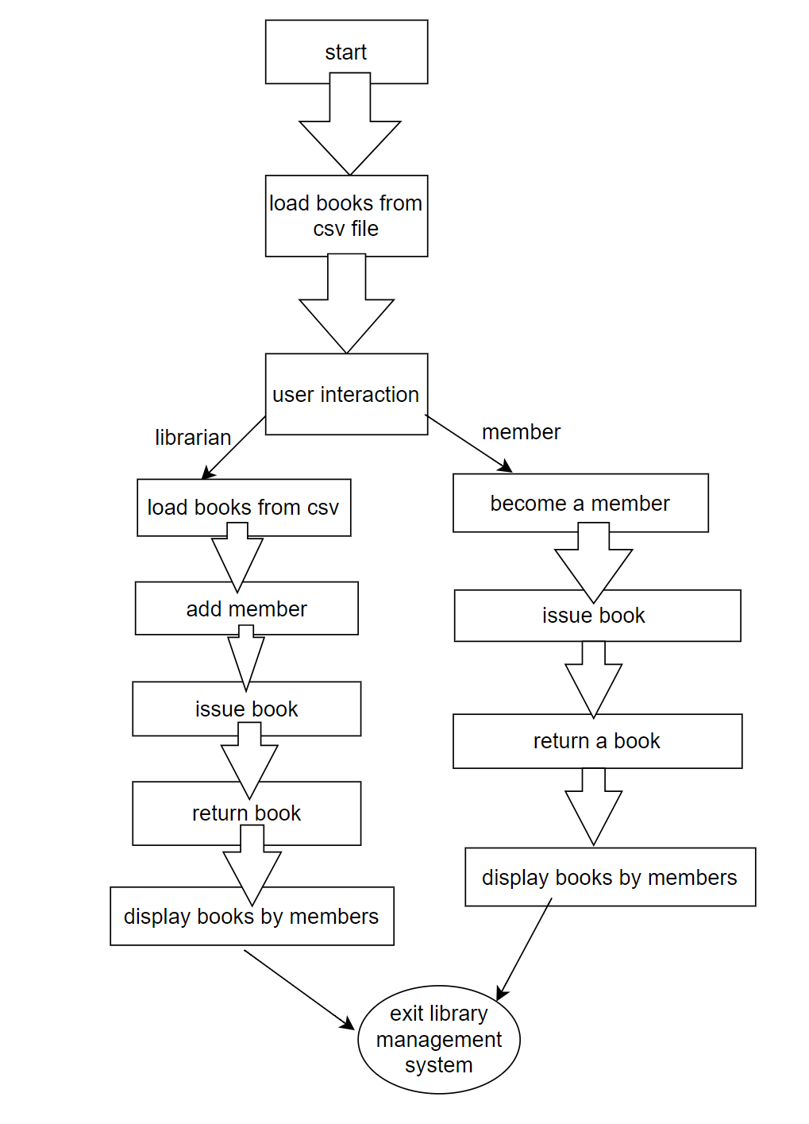

* This is my activity diagram for the library management system.
* The main advantage of the activity diagram it represent activities, actions, and control flows within the system.
* It shows how the roles of the librarian and user differ.
* The activity diagrams focus on representing the workflow or dynamic aspects of a system. Which illustrates the sequence of activities and actions within the library management system.

* This is the UMl diagram for the library management system.
* The UML (Unified Modelling Language) diagram is a visual representation of the library management system.
* Attributes are properties or data members of a class. They represent the characteristics or features of the class in this library management system
* Methods are functions or behaviours associated with a class. They represent actions that objects of the class can perform within the library management system
* For the member Class the attributes are member Id, name, email and address. The Methods I have used are borrowBook(), returnBook().
* Book Class: Attributes: book id
* For the Library Class the attributes are books (list of Book), members (list of Member). The Methods I have used are addMember(), issueBook(), returnBook(), displayBookByMember()

**Software Testing**

* I used Integration testing. After individual components were verified, the interactions between components.
* Prior to integration, each method—`addMember()`, `issueBook()`, `returnBook()`, and `displayBooksByMember()` underwent thorough individual testing to ensure both functionality and the absence of any bugs or errors. Only after confirming the reliability of each method were, they then were combined with the structures, classes, and the main function.
* However, the primary challenge with integration testing arises when combining methods with the main function, classes and structures often resulted in numerous bugs and errors in the code. Consequently, extensive debugging of my code and running numerous tests became necessary.

**Implementation**

* The code follows an object-oriented approach with structures (Book and Member) and a class (Library) to encapsulate related functionalities.
* The loadBooksFromCSV function demonstrates reading book details from a CSV file, showcasing file handling capabilities.
* User Interaction: The main() function provides a simple command-line interface for users to interact with the library system

**Implementation of Make File**

* The Makefile simplifies the build process by automating compilation and linking steps. I used variables like CXXFLAGS, to ensures consistent compilation settings across multiple source files.
* The make clean command is beneficial during development and debugging phases. It allows you to easily remove all generated files, ensuring that the next build is from scratch without any residual files
* I used the make command to build the project and used the make clean command to clean the project and remove all generated files.
* Overall the Makefile made it easier to manage my C++ project. Each section contributes to specifying the rules and dependencies required for a successful build.

**Version control and Implementation of Git**

* By utilizing Git commands, I successfully saved my source folder,catch2 and Makefile from Cygwin terminal to my GitHub repository, ensuring its secure storage.
* These are the following Git commands I used:
* git add .
* git commit .
* git push -u origin main
* below are screenshots off my GIT repository and commit messages

**Summary of work done and limitations**

* While the project aims to create a seamless library management system enabling users to effortlessly manage books and members by incorporating features like member addition, book issuance, and returns, the current code implementation requires further refinement to achieve this desired functionality.
* For example, the program is running well, the program is reading the excel csv file and printing it to the Cygwin terminal.
* However, when selecting option 2 or 3 to issue a book or return a book the program is not fetching the book id from the csv file. As a result when entering a book Id it prints an error message stating “invalid book id”.
* However, the rest of the program is working such as adding a member id and the books borrowed function.

**What I would do next time**

* In the future, I'll be diligent about committing my C++ code to GitHub regularly. The main advantage of utilizing Git is its capability to seamlessly track changes, ensuring that if errors emerge, I can revert to any prior version with ease.
* Initially, I stored previous versions of my code in separate files. Yet, upon discovering that GitHub offers a way to view and save past versions of my code, I understood that this extra step was redundant.
* I would also approach the way I start my code differently with more focus on functionality rather than design.